**Europe delivers its first equipment to light ITER’s fire**

[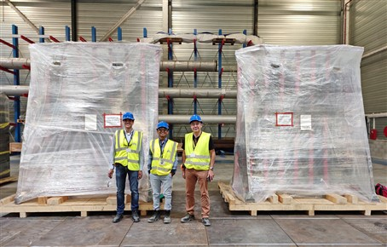](https://f4e.europa.eu/Downloads/News/ECPS_ITER_2_web-281020191200-Large.jpg)

F. Albajar, F4E Technical Responsible Officer, Darshan Parmar, ITER Organization Technical Responsible Officer, Paco Sanchez Arcos, F4E Project Manager, supervising the delivery of Europe’s first High Voltage Power supply unit delivered to ITER.

Several systems will be required to heat up the ITER plasma to 150 million °C. A mix of big components and auxiliary systems will provide high currents to achieve the biggest burning gas in a fusion device. Who would have thought that Europe's first unit, from a long list of components to raise the temperature at such unprecedented levels, would arrive on the ITER site from Switzerland famous for its cold snowy Alps. A mega trailer and three low bed ones, operated by DAHER, transported 40 t of equipment packed in 29 packages from Reikengen to Cadarache, France, where the action will unfold.

For [Ampegon](https://ampegon.com/), the Swiss small medium enterprise behind this technical achievement, the ITER requirements were no setback as it takes pride in controlling "the heartbeat of high power".  F4E began its collaboration with the company with the signature of an 11.5 million EUR contract for the manufacturing of equipment to supply with high voltage the Electron Cyclotron (EC) heating of the machine.

How does the EC work? This component works in a similar way to a powerful microwave oven that will heat up the super-hot gas. It converts electricity from the grid and supplies it to the gyrotrons, which by receiving energy generate strong electromagnetic waves to heat the ITER plasma. But here is a challenge: gyrotrons need high and stable voltages. This means that EC power supplies need to guarantee precise power supply, ensure it is in line with ITER's operation, and be able to switch it off in less than 10 micro-seconds! F4E has asked Ampegon to manufacture 8 of the 12 main high voltage power supplies (55kV/110A) and 16 body power supplies (35kV/100mA) to perform this task. The eight high voltage main power supplies can generate enough household electricity for 270 000 people - the population of a medium-sized city in Europe.

The delivery of the first main high voltage power supply on site, paves the way for more to follow. By 2021 the fabrication of the remaining seven will be completed and one year later their commissioning will be concluded. The collaboration between F4E and Ampegon started nearly [six years](https://f4e.europa.eu/Downloads/Press/Europe_signs_contract_with_Ampegon_to_heat_up_ITER_PR_100320141200.pdf) ago when the company had to [design](https://fusionforenergy.europa.eu/mediacorner/newsview.aspx?content=838) a fully customised equipment. Ferran Albajar, following the [entire lifecycle](https://fusionforenergy.europa.eu/mediacorner/newsview.aspx?content=1218) of the equipment on behalf of F4E, was there to witness the delivery. "It's great to see how years of work are finally paying off. We put a lot of effort in designing, testing, and checking the equipment in workshops. The moment it gets packed to be transported to ITER, it all starts coming together. You see the final destination and start imagining its operation," he explains.

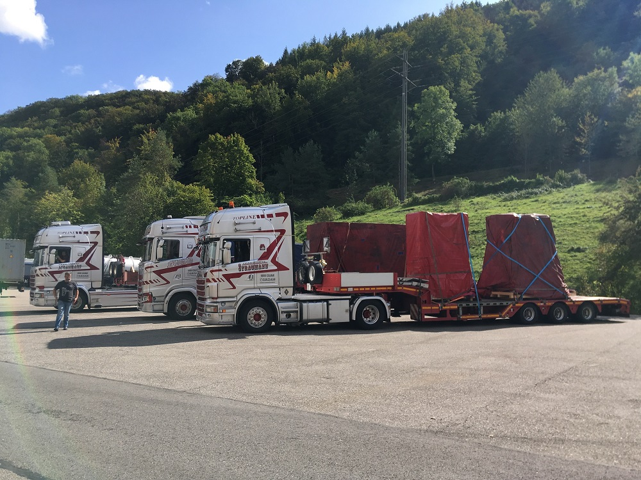

Loading completed for the first High Voltage Power supply unit, manufactured by Ampegon, before the trailers, operated by DAHER, depart from Reikengen, Switzerland, to Cadarache, France.

The excellent collaboration between F4E, Ampegon and ITER International Organization, with contributions from the Swiss Plasma Centre, and other experts deserve special mention. Tullio Bonicelli, Head of F4E's Neutral Beam and Electron Cyclotron, Power Supplies and Sources, stated that "the delivery of Europe's first plasma heating equipment to the ITER site has been successfully carried out. Our focus is now on the production of the remaining units and the successful commissioning".

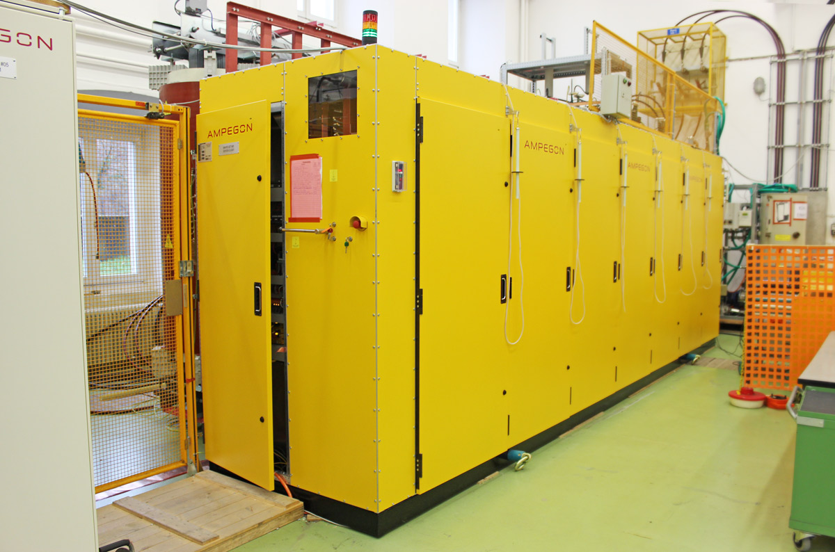

High Voltage Power supply unit procured by F4E and manufactured by Ampegon © Fusion for Energy

Simon Keens, Sales and Business Development Manager of Ampegon, explains why this has been an important achievement for the company. "We are proud to have been entrusted to supply the critical high-voltage power supplies to ITER. This project is of enormous significance to science and technology, and we expect that in future history will compare it to the moon landing! Not only is the ITER project extremely important for the future generation of clean energy, but the knowledge, understanding and cutting-edge power electronics developed will also support new industrial processes in the future."

Michel Hubner, Switzerland's Industry Liaison Officer for ITER, who has been actively promoting the business angles and opportunities of the project to Swiss companies and laboratories, took the opportunity to highlight the significance of this milestone. "We are very pleased that AMPEGON has delivered the first gyrotron power supply unit to Cadarache, on time and in line with the F4E specifications. The size of the project and its complexity, make AMPEGON the flag carrier among all Swiss suppliers to ITER. Power electronics is one of the technical domains where Switzerland performs well in the international high energy physics research market. We are happy to have set a further landmark in this domain within the prestigious fusion energy project."